UNIVERSITY OF MACAU

CISC7204 Data Science and Data Visualization
Assignment 01 - Preliminary Project Proposal

PROJECT TITLE:

Explaining Global Happiness: Comparative Analysis of Economic Factors vs. Health Indicators

Course Code: | CISC7204
Course Title: | Data Science and Data Visualization
Coursework Item: | Assignment 01 - Preliminary Project Proposal
Student Name: | Luo Yawen
Student ID: | MC656094
Submission Date: | 19/9/2026
Explaining Global Happiness: Comparative Analysis of Economic Factors vs. Health Indicators

Research Focus & Data Foundation

Research Question
Around the world, which does a better job explaining happiness—per capita GDP or health expectancy? Specifically, this study investigates how strong the relationship is between happiness and economic indicators versus health indicators individually (in terms of correlation and $R^{2}$), whether economy and health are closely linked to each other and how that affects a model including both, as well as how each factor's individual impact on happiness changes in a combined model.

Region & Domain
Region: Worldwide (covering more than 150 countries and regions)
Domain Category: Socioeconomics, Public Health, and Wellbeing Analytics

Data Sources
This project integrates two public open datasets from Kaggle and authoritative international organizations:
Dataset 1: World Happiness Report
Link: https://www.kaggle.com/datasets/unsdsn/world-happiness
Description: Provides national happiness scores, per capita GDP contribution, social support, and healthy life expectancy across countries (2015–2019).
Dataset 2: Life Expectancy (WHO) Data
Link: https://www.kaggle.com/datasets/kumarajarshi/life-expectancy-who
Description: Published by the WHO, containing country-level socioeconomic indicators, development status (developed/developing), and healthy life expectancy (in years).

Project Purpose and Significance

Outcomes
This project directly aligns with core course objectives by integrating "World Happiness Report" socio-economic indicators with WHO public health data to solve complex real-world analytical problems. It solidifies my quantitative foundation for advanced data science and computational analysis studies while honing essential skills in data cleaning, econometric modeling, and data storytelling. These capabilities build the core competencies required for data analyst or data scientist roles.

Skills
Data Cleaning and Integration: Utilizing Python (Pandas) to standardize country naming conventions across distinct datasets, handle missing values, and execute relational inner joins.
Statistical Modeling and Diagnostics: Calculating Pearson correlation matrices, fitting univariate and multivariate Ordinary Least Squares regressions, and evaluating goodness-of-fit ($R^{2}$, Adjusted $R^{2}$), $p$-values, and multi-collinearity.
Data Visualization: Leveraging Matplotlib and Seaborn to generate distribution plots, boxplots, correlation heatmaps, and regression scatter plots with 95% confidence intervals.

Knowledge
Gain a deep understanding of core data science concepts, including multicollinearity, goodness of fit ($R^{2}$), adjusted $R^{2}$ with its complexity penalty mechanism, and feature standardization.

Experimental Tasks

Task 1: Data Import, Cleaning and Integration
Extract data from the 2015–2019 World Happiness Reports and WHO life expectancy data, and uniformly clean the strings in the Country column. Associate fields from the two tables, filter out missing values, and extract the three core variables: Happiness_Score, GDP_per_Capita and Life_Expectancy_Years.

Task 2: Descriptive Statistics and Exploratory Data Analysis
Calculate the mean, median, and standard deviation of the three core variables. Plot variable distribution histograms (with KDE curves) and boxplots in a $3×2$ layout to examine skewness, multimodal patterns, and outliers.
 | Happiness_Score | GDP_per_Capita | Life_Expectancy_Years
Mean | 5.384 | 0.848 | 72.07
Median | 5.194 | 0.919 | 74.50
std | 1.159 | 0.406 | 8.38
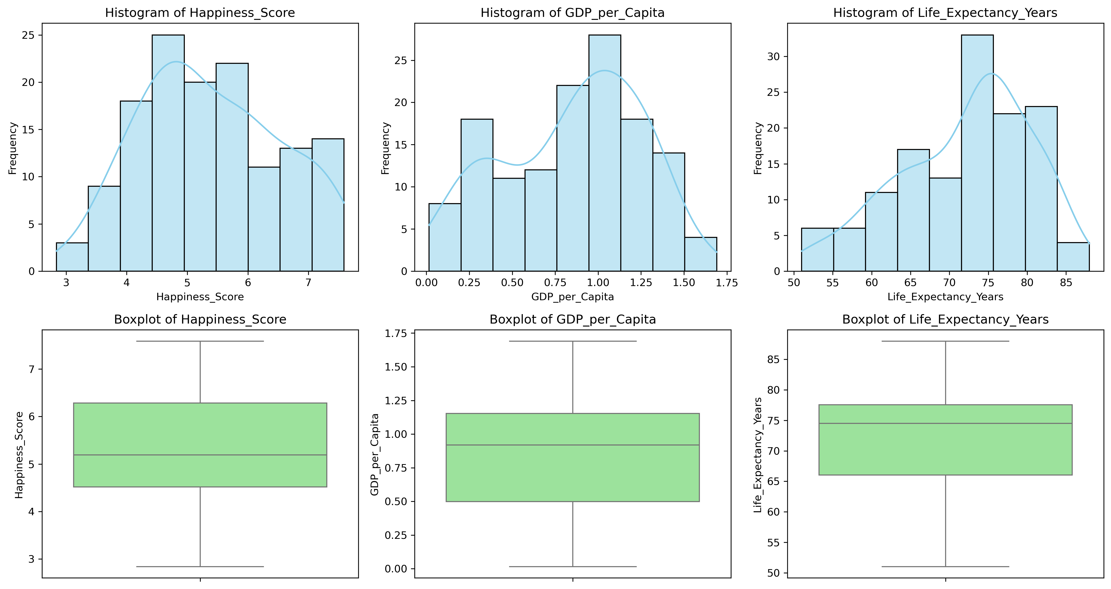
Distribution & Boxplot Characteristics (EDA Findings): Happiness_Score presents an approximate normal distribution with minor middle-range fluctuations. Life_Expectancy_Years exhibits a clear left-skewed distribution, showing that the average life expectancy for most countries is heavily concentrated between 70 and 80 years old. GDP_per_Capita demonstrates a noticeable bimodal distribution, reflecting global economic stratification between developing and developed nations.
Task 3: Correlation Analysis and OLS Regression Modeling (Statistical Inquiry)
Calculate the $3×3$ Pearson correlation coefficient matrix and plot a heatmap. Construct three sets of OLS models:
Univariate Model 1: Happiness∼GDP_per_Capita
Univariate Model 2: Happiness∼Life_Expectancy_Years
Multiple Regression Model: Happiness∼GDP_per_Capita + Life_Expectancy_Years
Correlation coefficient：
${\text{Correlation}}_{\text{Happiness, GDP}}$ = 0.799 （Strong positive correlation）
${\text{Correlation}}_{\text{Happiness, Life Exp}}$ = 0.749 （Strong positive correlation）
${\text{Correlation}}_{\text{GDP, Life Exp}}$ = 0.820 （strong positive correlation, indicating that there is overlapping information among the independent variables）
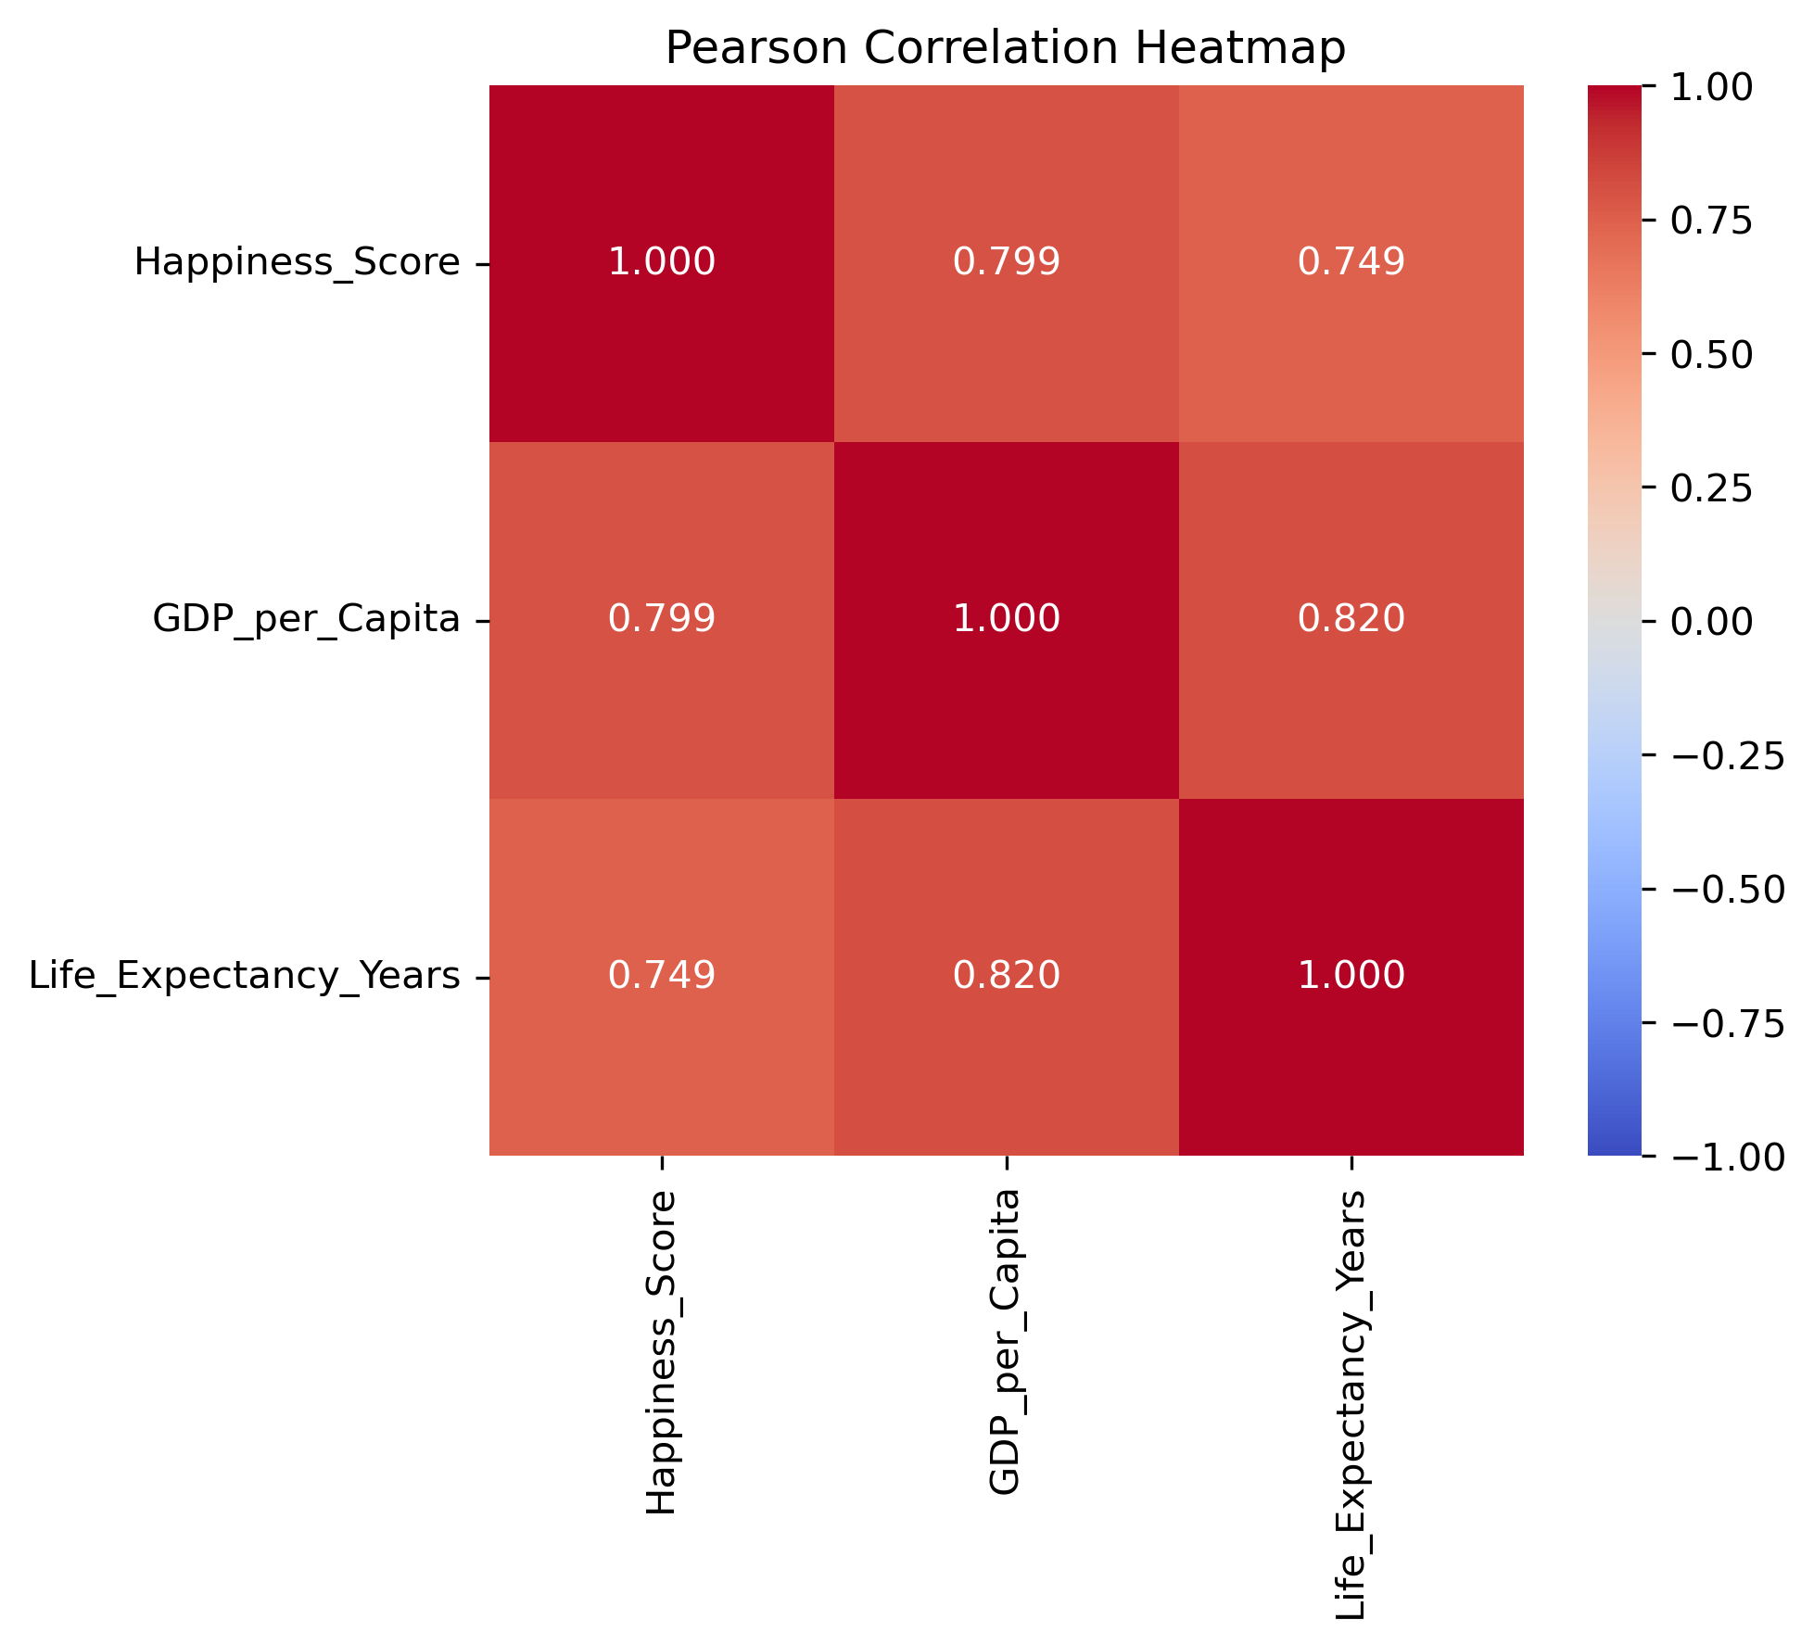
Model Comparison Table:
Model | Intercept | Coef (GDP) | Coef (Life Exp) | R-squared | Adj R-squared
GDP | 3.449 | 2.283 | — | 0.638 | 0.636
Life Exp | −2.075 | — | 0.104 | 0.561 | 0.557
GDP + Life Exp | 1.170 | 1.613 | 0.039 | 0.665 | 0.660

Task 4: Visualization Rendering and Analysis Report Writing (Visualization & Reporting)
Plot side-by-side regression trend scatter plots.
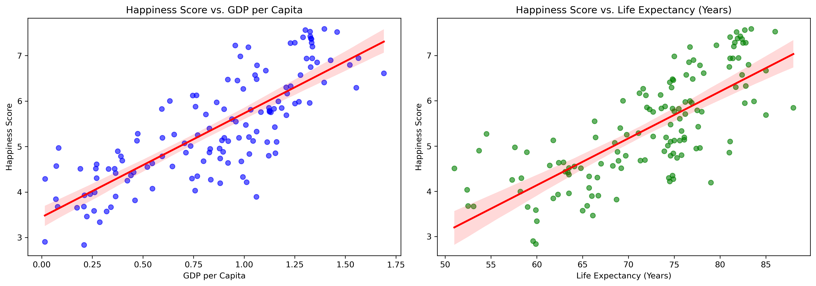
Explanatory Power of Single Predictors: In simple linear regression, per capita GDP ($R^{2}$= 0.638) explains global happiness significantly better than healthy life expectancy ($R^{2}$ = 0.561). This confirms economic income as the single most critical driver, explaining 63.8% of cross-country differences on its own.
Joint Effects & Coefficient Squeezing: Including both variables in the multiple regression increases goodness-of-fit to $R^{2}$ = 0.665(66.5%). However, coefficients drop for GDP from 2.283 to 1.613 and life expectancy from 0.104 to 0.039. This "coefficient squeezing" directly stems from their high correlation ($r$ = 0.820), allowing the model to isolate each factor's net marginal effect after removing overlapping information.
Trend Visualization & Policy Implications: Side-by-side scatter plots show strong positive linear trends with narrow 95% confidence intervals. This indicates that relying solely on economic growth or isolated health improvements yields diminishing returns. Sustainable policy must focus on transforming economic gains into healthcare and social welfare systems.

Criteria for Success
This project’s deliverables are assessed against two strict criteria: Data Merging Quality, which requires successfully cleaning, matching, and retaining complete panel data for over 130 countries without missing key independent variables; and Statistical Rigor, which demands establishing standardized OLS models with clearly reported p-values, correlation coefficients (r), R², and adjusted R² to rigorously address core research questions using quantitative evidence.

Collaboration Issues
Luo Yawen (mc656094): Co-managed project planning and task execution; took charge of dataset acquisition, research design, Python data cleaning, and EDA; contributed to regression modeling, visualization, drafting all sections, document formatting, and final proofreading.
Xu Yiting (mc652844): Co-managed technical validation and pipeline design; took part in research hypothesis framing and code structure optimization; contributed to regression modeling, visualization, statistical interpretation, drafting report sections, model verification, and text polishing.

